The Automated Additional Pay System enables employees to enter all additional work performed on campus into an automated system that calculates the employee’s available time in compliance with California State University Additional Employment Policy, HR 2002-05 (http://www.calstate.edu/hradm/policies/hr2002-05.pdf). All additional work entered in this system requires a two-step process: a Pre-Authorization, and a Payment Authorization. Pre-Authorizations must be entered for all University Corporation work before the work is performed. No exceptions. As such, we highly advice employees to plan out their additional work ahead of time.

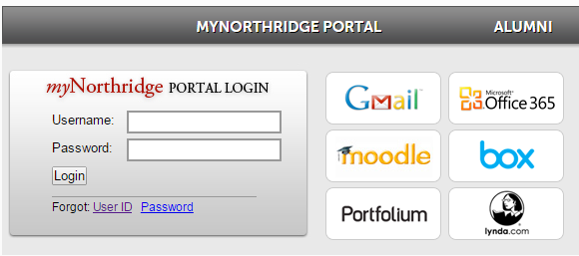
Step 1 – Logging In

Log into the myNorthridge Portal

Once logged in, locate the Additional Pay pagelet and click on the TUC Pre-Authorization link.

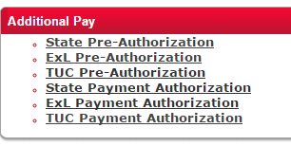

Step 2a – Searching for Existing Values

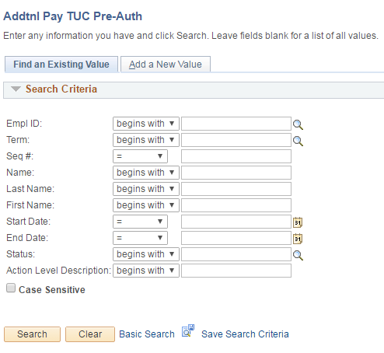
Once in the Pre-Authorization page, there are two options: Find an Existing Value and Add a New Value.

On the Finding an Existing Value tab, you can search for any Pre-Authorizations you have entered previously by entering the employee’s information in the appropriate search fields.

You may also just hit the “search” button without entering any information, and any previously entered Pre-Authorizations should come up.

Step 2b – Adding a New Value

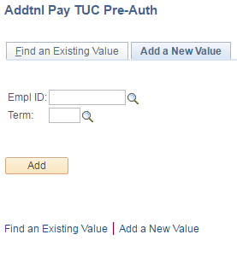
On the Add a New Value tab, enter the information of the employee who will require the Pre-Authorization for special pay.
1 – Enter the employee’s CSUN employee ID number
2 – Enter the term that the special pay will be for, such as Spring 2016. Please note: You cannot enter any past-dated information. All information entered must be for work in the future.

2
1

2
1
You may click on the magnifying glass icon to look up employees by name, or to search for the appropriate term you would like to select.

The Pre-Authorization Screen

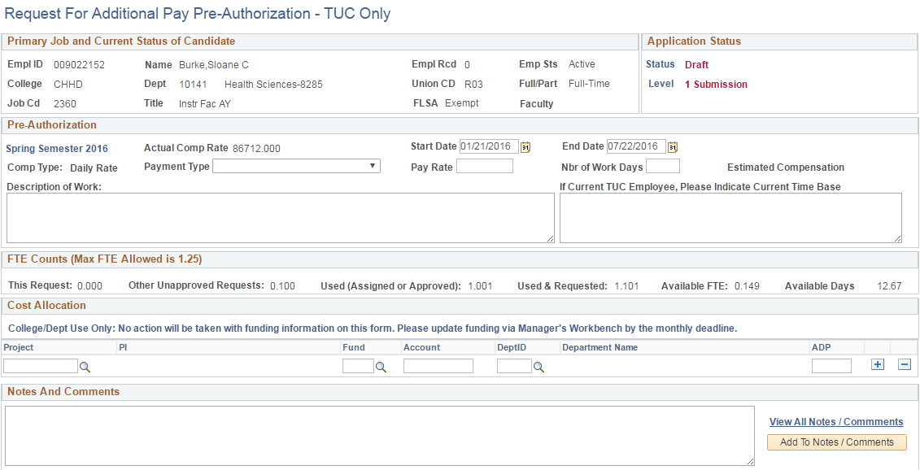
The total FTE will display, prior to entering the new information. In this case, the faculty employee has a total of 1.001 FTE, and available balance of 0.149. The available days for the term chosen also displays. In this case it equates to 12.67 days.

The Request for Additional Pay Pre-Authorization page provides information on the employee’s current primary appointment under the Primary Job and Current Status of Candidate section. In this example, the employee is an Active, Full-Time Instructional Faculty AY in the department of Health Sciences.

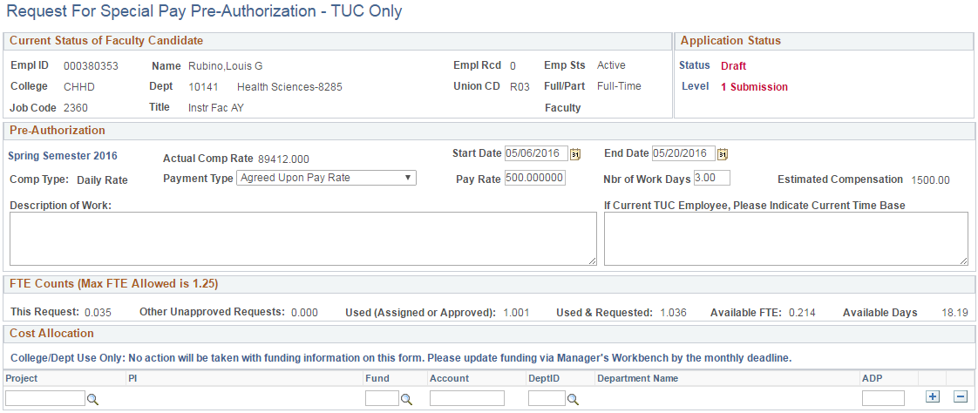
Step 4 – Entering Information
The next step is to enter a Start and End Date, select the Payment Type, enter the Pay Rate and the Number of Work Days the employee will be working.
The Payment Type dropdown menu provides two options: 1) Agreed Upon Pay Rate and 2) Base Salary Pay Rate. If the agreed upon pay rate is chosen, the agreed amount should be entered in the Pay Rate section. Otherwise, if the base salary pay rate is selected, the system will automatically populate the Pay Rate section with the employee’s primary appointment salary information.
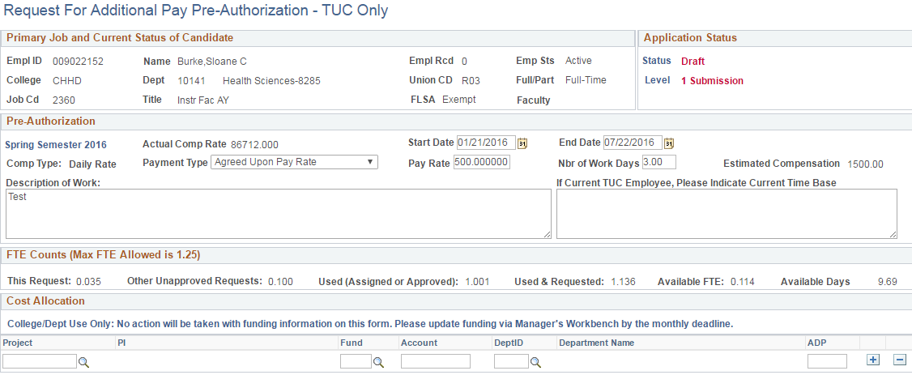

In the example above, Agreed Upon Pay Rate was chosen as the payment type, with a pay rate of $500, and 3 days of work. Based on this information, the system has calculated how much time this appointment will take up (0.035 FTE), and how much available time is left for this employee to use for the remainder of the term selected (.114 FTE, or 9.69 days).

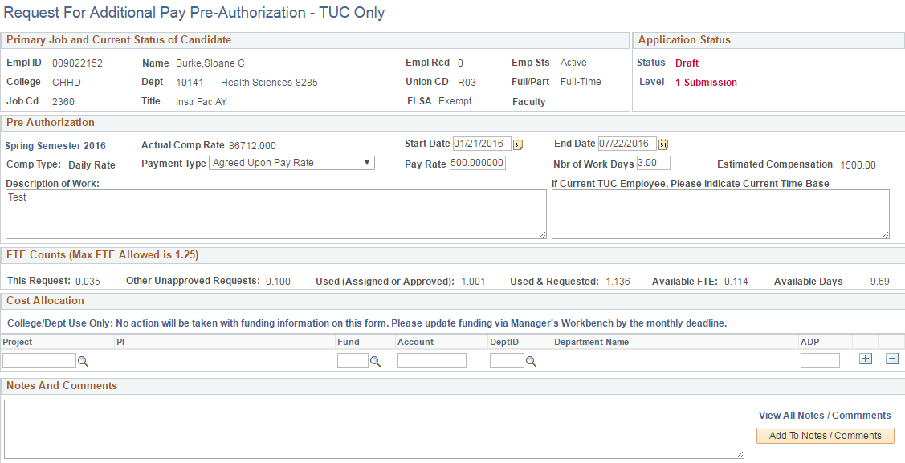
A Description of Work that will be performed by the employee must be entered in the request. If the employee is a current TUC staff employee, ensure to provide that appointment’s time base.
Next, a Project ID or Fund number must be included in the request. The magnifying glass icon can always be used to search for the correct Project or Fund number needed. You can include notes to your request if needed.
Once all information needed for the request is complete, you may click on the Submit button:

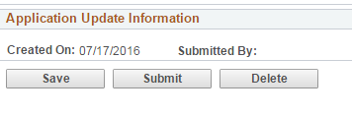

The request will then go through the following levels of approval:
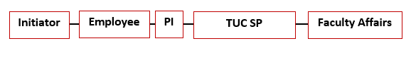
If the employee who is requesting the additional pay is a PI, then the levels of approval will be as such:
MAR
TUC SP Approval
Faculty Affairs
Initiator
PI
Employee

Once all levels of approval are complete, the request will move to the Payment Authorization stage and will remain in “submission” status until the work has been completed and the employee or initiator is ready to certify and enter the dates of the work completed.

Payment Authorization Stage
Once the employee has completed the work, a Payment Authorization may be initiated. To access the Payment Authorization, follow Step 1 on this guide. Once logged in, locate the Additional Pay pagelet as shown below, and select that TUC Payment Authorization link.
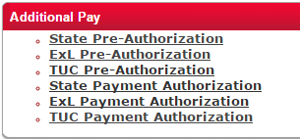

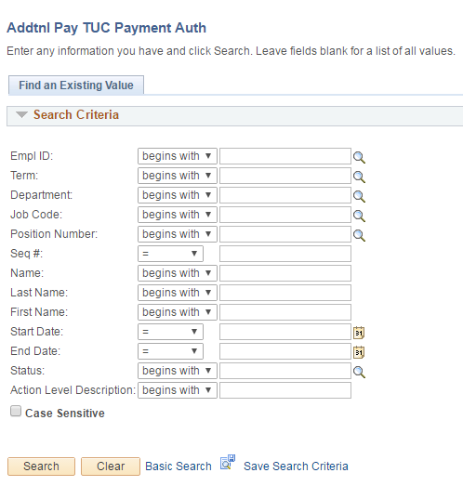

A new page will open where you will be able to find existing values. Notice that under the Payment Authorization there is no option to “add a new value”. This is because no payment authorizations can be initiated without a pre-authorization of the work.
To find existing values, you may search for the employee by entering the Employee ID, or you may search for that employee by clicking on the magnifying glass. You may also just hit the “search” button to pull up all your current existing values.

Step 4 – Entering Completed Work

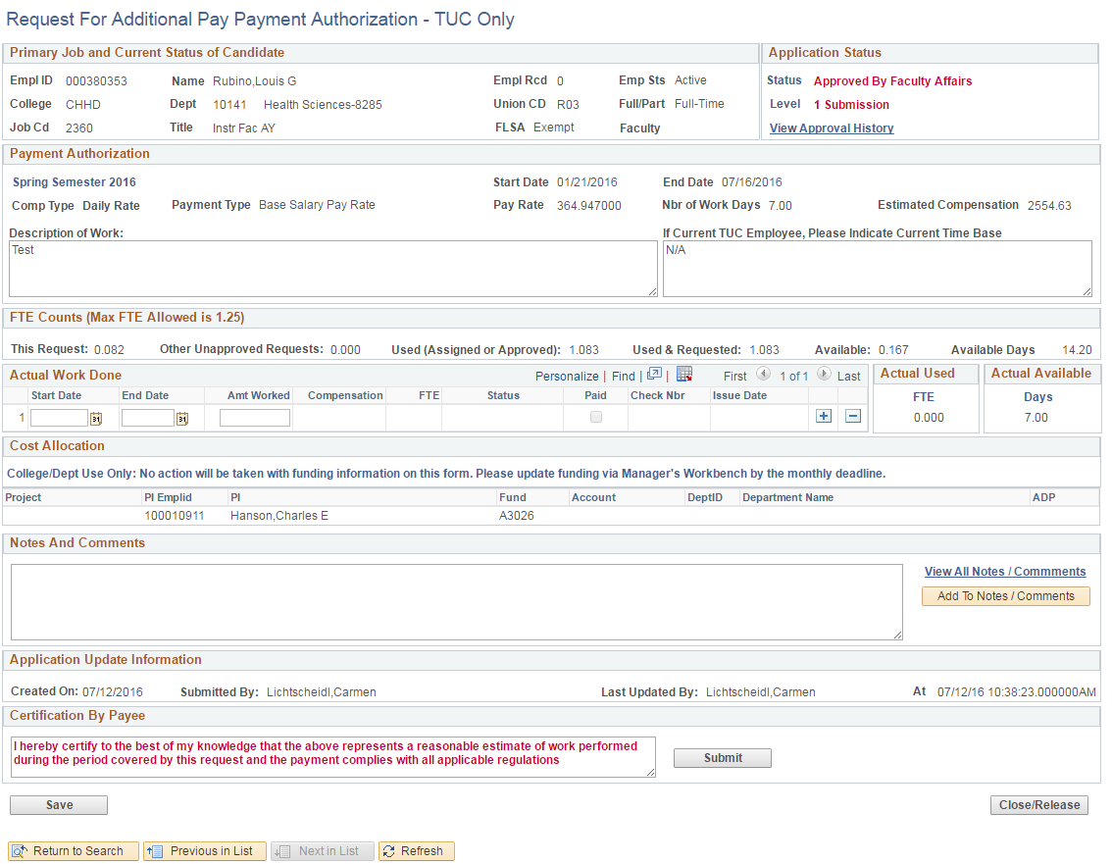
In the Payment Authorization page, the information entered previously through the Pre-Authorization is displayed (see example below). The next step is to enter the Actual Work Done. Please note: Future dates cannot be entered. This section must be completed after work has been performed.
Under the Actual Work Done section, select the Start Date and End Date of when the work was performed. You may either enter the dates, or click on the calendar icon to select dates. Next, enter the total number of days worked under the Amount Worked section. Entering this information will automatically calculate the compensation total and the FTE used.
You may enter comments in the Notes section if needed, otherwise you may hit the “submit” button, which will certify that the information entered complies with all applicable regulations.
Once the information for work completed has been entered and submitted, the request will then go to the approver next in line, until it reaches the last level of approval to issue payment.
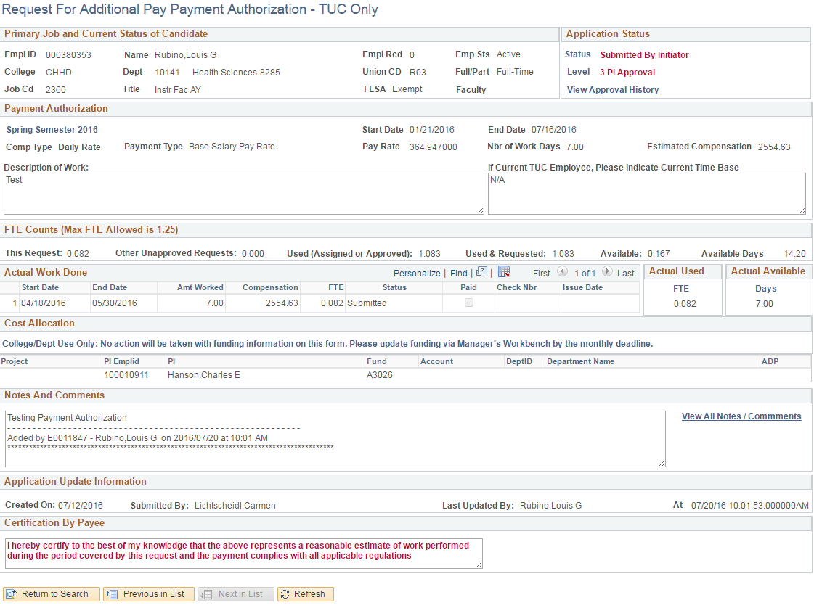

If for any reason the employee is not able to perform the work he/she has agreed to and submitted as a pre-authorization, the “Close/Release” button option is available in the Payment Authorization page to release the time that had been reserved by the pre-authorization request.

