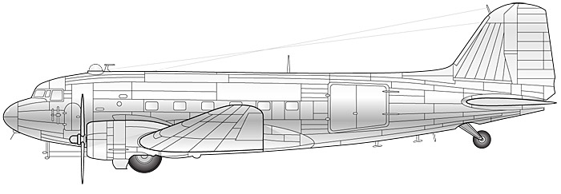

Draw vector diagrams to illustrate the forces acting upon (A) a cruising plane; (B) an accelerating skydiver; (C) a skydiver in constant descent; (D) a man standing on the ground

