Study Guide for Microscope Tutorial

With your microscope, follow the directions on this sheet to learn more about how your light microscope functions. Go through the tutorial. Watch all the videos. Click on the bookmarks at the bottom and experience those different websites. When you have done that, follow along with these questions to complete the tutorial.

1. Fill in the parts of this scope. Check your answers by double-clicking on the picture in the tutorial.

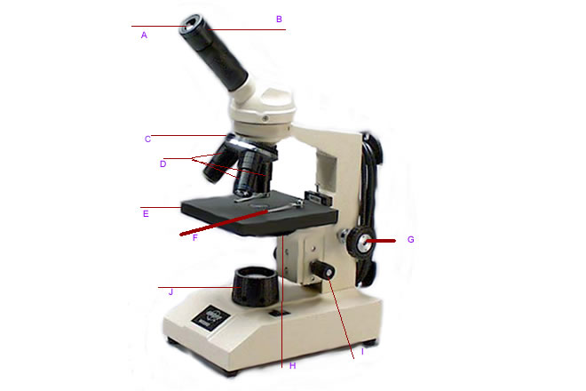
2. What is the correct way to carry your light microscope?

3. Again, watch video #1. I am using the 40X objective lens. What is the total magnification of the specimen?

4. In front of you, you have a slide, the letter “e”, water and a cover slip. Follow the directions on the second video to make your slide. Why does the coverslip have to be placed on the slide diagonally?

5. Watch the third video again. Place your slide on the scope correctly and using the lowest objective, focus in on the “e” on your slide. Why do you think it is important to start with the smallest objective?

6. Watch the last two videos, #5 and #6 on how the image you see is the mirror image of the specimen. Try to move your IMAGE to the right, which way did you have to move the slide? Center the “e” back in the middle of the scope. Now move the image to see the very top of it. In what direction did you move the slide on the stage?

7. Look again at video #4, increase the magnification of your “e” from 40X to 100X. What adjuster should you use now to focus in on the larger image? Why?

8. What are two things you learned from the first bookmark, the animated tutorial?
a.

b.

