

fall 2012 Prof L Overman's English 115
WEEKLY SCHEDULE 6-10
Class | Monday | Wednesday
Wk 6 | 10/1 | 10/3
Progression One  Persepolis & Convergences | Due outside of and prior to class:  - Moodle response 4  Due in Class:  - Rhetorical Analysis #4 Iranpur (ec) & Babbes  Review & download handouts from Projects link above:  - Progression Two  Readings:  - Convergences 164-167  - Persepolis 1-53  Review/download handouts from Projects link above:  - Observing | Due outside of and prior to class:  - Prog 2 Ex 1 The “Ethnography”  Due in of class:  - Rhetorical analysis presentation #5 Litke & Bush  - Grammar Pres #5 on missing comma in a compound structure by Knight & Rasul  - Groups assigned for The Scene on 10/17  Readings:  - Convergences: "Mini-Narratives" 187-197  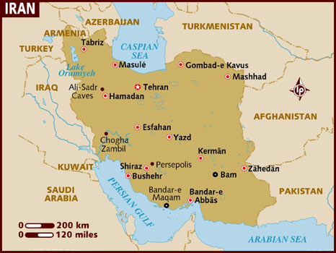
Wk 7 | 10/8 | 10/10
Persepolis & Convergences | Due outside of and prior to class:  - Prog 2 Ex 2 “The Word Picture”  Due in of class:  - Rhetorical analysis presentation #Gabrielyan & Jose Rodriguez  - Grammar Pres #6 on unnecessary or missing apostrophe by Ruiz & Huezo  Readings:  - Convergences 181-186  - Persepolis 54-102 | Due outside of and prior to class:  - Moodle response 5  Due in of class:  - Rhetorical analysis presentation #7 Rasul & Iranpur  - Grammar Pres #7 on fused(run-on) sentence by Ibarra & Miwa  Readings:  - Convergences 208-218  - Wings 66
Wk 8 | 10/15 | 10/17
Persepolis & Convergences | Due outside of and prior to class:  - Moodle response 6  Due In Class:  - Rhetorical analysis presentation #8 Mendez-Herrera & Corona  - Grammar Pres #8 on comma splice by Loughran & Bush  Readings:  - Persepolis 103-end  - Convergences 254-278 | Due outside of and prior to class:  - Prog 2 Ex 3 “The Scene”  - By 12midnight email me loverman@csun.edu the grades you feel each group member has earned...using the Group Participation Rubric in Syllabus. This will be averaged into your Prog 2 comprehensive grade!  Due In Class  - Rhetorical Analysis Presentation #9 Miwa & Ying  - Groups act out The Scene  Readings:  - Convergences 448-449
Wk 9 | 10/22 | 10/24
Progression Two rough draft due | Due outside of and prior to class:  - Due Fri 10/19 1155PM entire class post Progression Two rough drafts-make sure you post correctly in one of the Three forums provided!  - Due Sun 10/21 1155PM Post in Workshop 3 Forum response to each student's below rough draft. Students work to be dicussed  Facilitator/Writer  Ibarra/Mendez  Iranpur/Litke  Khan/Knight  Kim/Babbes  - Review Writing Response Protocols handout in Projects link above.  Due in class:  - Whole-class workshop 3 | Due outside of and prior to class:  - Due Mon 10/22 1155PM Post in Workshop 4 Forum response to each student's below rough draft. Students work to be dicussed  Facilitator/Writer:  Steadman/Briones  Ruiz/Bush  Rose/Ying  Jose Rodriguez/Kim  - Review Writing Response Protocols handout in Projects link above.  Due in class:  - Whole-class workshop 4
Wk 10 | 10/29 | 10/31
Upload Progression Two Revised onto your Blogs & Begin Progression Three | Due outside of and prior to class:  - Upload Progression Three on blog prior to class must follow MLA format but feel free to include multi media  Due in Class:  - Grammar Pres #9 on lack of pronoun-antecedent agreement by Ying & Gabrielyan  - Groups assigned for Final Project  Review & download handouts from Projects link above:  - Progression Three  - Evaluating Web Design  Readings:  - Convergences:286-289 | Due outside of and prior to class:  - Moodle response 7  Due in Class:  - Rhetorical Analysis Presentation #10 Montalban & Knight  - Grammar Pres #10 on poorly integrated quotation by Kim & Briones  Review & download handouts from Projects link above:  - Structure Argument Takes #17  Readings:  - Convergences:290-313
- Updated on 8/28/12

