LESSON PLAN

Topic: Analyzing Tobacco Ads

Name: Jolene Kuebler
Class: Health
Grade Level: 9-12

Major Concepts:
Tobacco Prevention

Performance Objective / Content Standards:
Students will realize that advertisements have many hidden meanings and use lies to try to convince you to purchase their product by using a certain type of selling trick.
Health Standard #5: Alcohol, Tobacco and other drugs

Goals:
Specific to Lesson:
-Students will be aware that Cigarette advertisements are manipulative and trick consumers to purchase their product using covert methods.
-Create an anti-tobacco advertisement that shows the harmful effects of tobacco use.
Specific to Unit:
-Students will know the short-term and long-term effects of tobacco. (Addressed in previous lessons)
Broad Subject:
-Students will understand the harmful effects of tobacco use and second hand-smoke. (Addressed in previous lessons)
Long-term goals:
-Work cooperatively with others
-Students will engage in self-learning through interactions in the environment.
-Learners will learn with desire.
-Students will take initiative as learners.
-Students will think critically.
-Students will value their classmates even if they learn differently from them.

Materials and Equipment:
Tobacco ads (laminated)- provided by teacher
Tricks of the trade Handout
Advertisement Questions Worksheet/Poster Criteria
Poster paper
Markers
Scissors
Overhead projector
LCD projector
Teacher laptop
Student Laptops

Assignment:
Analyze a tobacco ad in pairs and answer questions from the worksheet provided by the teacher.
Outline of Lesson:
- Warm-up: Show an example of an advertisement on the overhead and ask the class questions. They will write their answers on a piece of paper that will also be found on a handout given to them later. (10 min.)
- Lecture: Explain different types of tricks advertisers use to get the public to purchase their product. Given as a handout and shown on overhead. Introduce the different pressures that are used in advertising- Direct, Indirect (10 min.)
- Ask the class what they believe the U.S. tobacco advertisers spend on advertisements every year ($11,000,000,000)
- Instruction: (8 min.)
  - Teacher will place students into pairs quietly and give them an advertisement.
  - One student will hand out Group worksheet and poster paper.
- Activity: (20 min.)
  - Students will analyze the tobacco ad that is given to them.
  - Students will answer the questions on their worksheet pertaining to the advertisement onto a poster paper to be presented to the class later.
  - Students will make sure the names of the members of their group are on the paper and poster along with the class period.
  - Students will turn in their paper and poster to be finished in class the next day, or they may take it home to complete it.
  - Presentations will be done in class the following day.
- Early Finishers:
  - The students that finish their worksheet and poster first can create an anti-tobacco ad in pairs. (Opposite of their assigned advertisement)
  - Students can assist other groups in determining the advertising trick used.
  - Students that are having a lot of difficulty will receive assistance from the teacher.
Next day follow-up:
- Revisit tricks of the trade handout.
- Look at the advertisement presented on the first day and see if they feel differently about it after learning the tricks of the trade.
- Finish up Ad analysis poster.
- Present posters.
- Share homework
Homework:
*Bring in an advertisement for a product you find outside of class: billboard, magazine, Internet, commercial on TV. Answer the questions that were given to you on the handout. Would you purchase this product after learning about the tricks advertisers use? (20 points) OR

*Create anti-tobacco advertisement (20 points)

(extra credit if both are completed- 40 points)
References:
TND= Towards No Drug Abuse- mandated curriculum (11 lessons), MSPP= Minnesota Smoking Prevention Program- mandated curriculum (7 lessons)
Group Members:___________________________________________Period____

AD Analysis Questions

Answer these questions and write them neatly on your poster
- What product is being advertised? How?

- Describe the people and or images used in the advertisement. What does the appearance of these people and/or images imply (suggest, say) about the product?

- What specific information about the product is provided? Example: Less fat? Non-addicting? What information would you want to know about this product?

- What is the advertiser trying to get you to believe? Example: our product is better. Is this true? Explain.

- What advertising technique are they using? Why does it fall into that category?

- Would you purchase this product? Why or why not?

Name_________________________________________________ Period_______

AD Analysis Homework

Find an advertisement for a product, preferably in a magazine or newspaper. If you do decide to use an advertisement used on TV. or the Internet make sure to write a small paragraph explaining the advertisement or bring in a copy of it. Attach the copy to this sheet.

Answer the following questions:
- What product is being advertised? How?

- Describe the people and or images used in the advertisement. What does the appearance of these people and/or images imply (suggest, say) about the product?

- What specific information about the product is provided? Example: Less fat? Non-addicting? What information would you want to know about this product?

- What is the advertiser trying to get you to believe? Example: our product is better. Is this true? Explain.

- What advertising technique are they using? Why does it fall into that category?

6. Would you purchase this product? Why or why not?

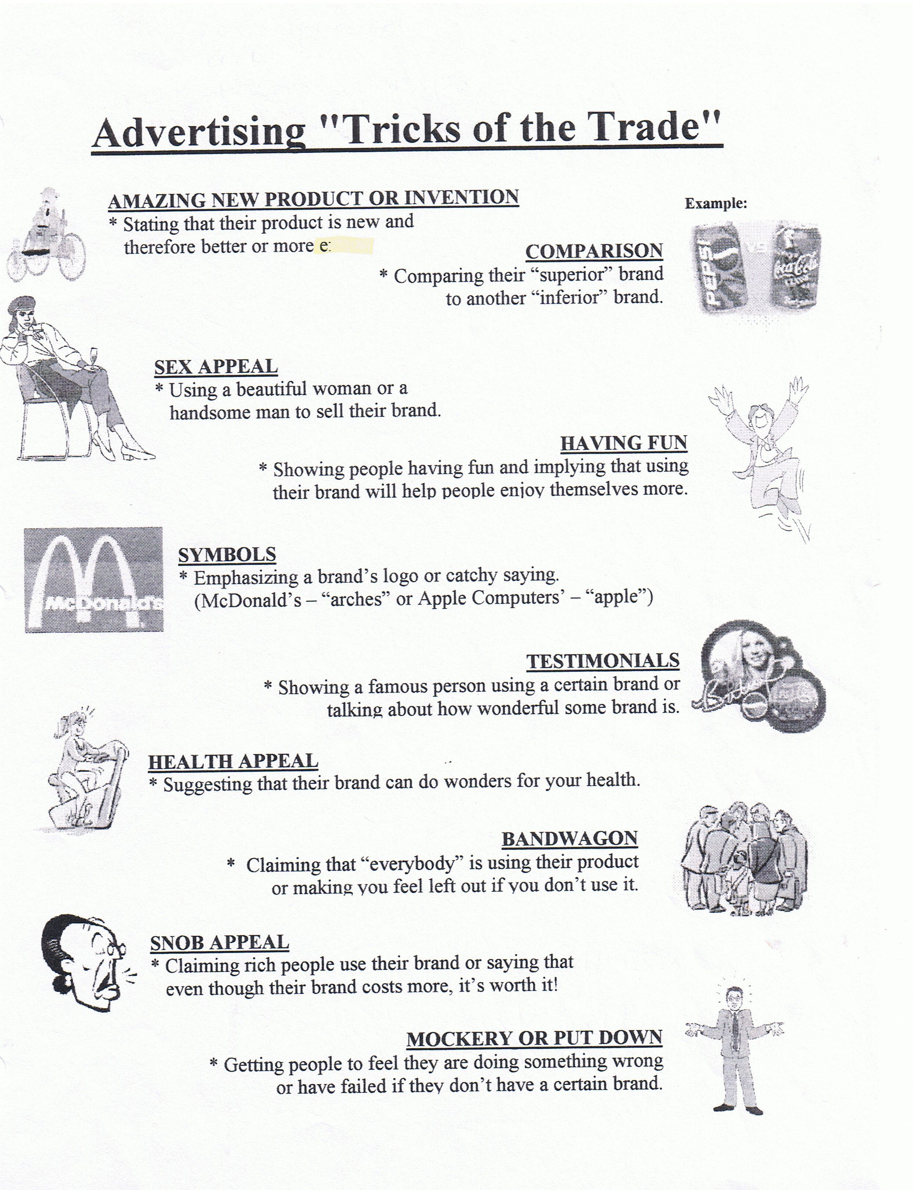
▪Slogans and Jingles
▪Before and After
▪Positive Images
▪Demonstrations
▪Macho
▪Adventure
▪Freebies

