Exploring The Pythagorean Theorem

Grade: 7th grade pre-algebra

Time: 50 minute period

Objectives:
- Students will be able to implement their knowledge of the Pythagorean Theorem into real-life situations.
- Students will be able to gain a better understanding of why this theorem is important.

CA State Content Standards: Measurement and Geometry
- 3.3 Know and understand the Pythagorean Theorem and its converse and use it to find the length of the missing side of a right triangle and the lengths of other line segments and, in some situations, empirically verify the Pythagorean Theorem by direct measurement.
Prior Knowledge: Students have been using the Pythagorean Theorem to find the missing length of right triangles.
Students will be working collaboratively in groups of 4. They will be grouped depending on their ability of how they did on the pre-assessment. I will also take into account which students work better in groups than others. On the each of the desks in the group there will be a different colored sticker indicating their responsibility to their group. (task manager-materials-the enquirer-not sure yet) Everyone is a recorder.
Warm-up: Students will respond to: Can we use the Pythagorean Theorem to answer questions about a baseball “diamond”? Why or why not? Students will be given a picture of a baseball “diamond” with accurate measurements. Students will then discuss their findings with their group members. Students will respond to: Is the baseball “diamond” really a diamond? Is it any other shape?
Group Work: There will be four different situations using various types of fields and courts that sports are played on. Each situation will be explored by two different groups. We will be able to compare and contrast the two groups’ findings. I will be differentiating this lesson by giving different groups different scenarios depending on their ability level.

Depending on the situations students may or may not be given a layout of the court or field. They will be accessible if needed.
Situation A given to 2 groups:
The distance between each of the consecutive bases on a baseball “diamond” is 90 feet. How far does the 2nd baseman have to throw the ball to get the runner out at home plate?
You've just picked up a ground ball at first base, and you see the other team's player running towards third base. How far do you have to throw the ball to get it from first base to third base, and throw the runner out?

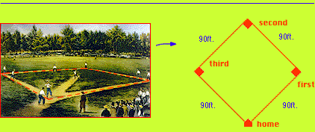

Students will not be given the layout of this baseball field at first. It will be available if I feel they need it.

Situation B given to 2 groups:

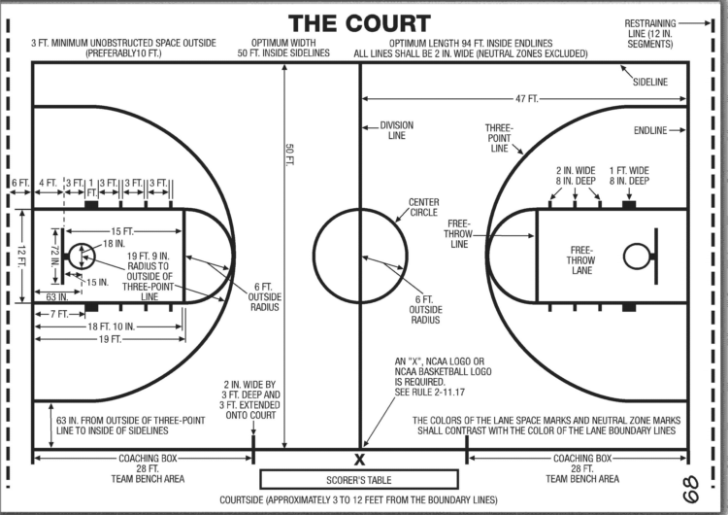

Students will be given questions to answer given this layout of a basketball court.

Situations C given to 2 groups:

Students will have to draw their own soccer field given the dimensions and then answer questions relating to the Pythagorean Theorem and their layout of the field.
The field of play shall be rectangular, the width of which shall not exceed the length.
The optimum size is 75 yards (68.58m) by 120 yards (109.73m).

Goals must be placed on the center of each goal line. They consist of two upright posts equidistant from the corner flag posts and joined at the top by a horizontal crossbar. The distance between the posts is 8 yds (7.32 m)

You just got kicked by another player. It is time for your penalty kick. You are positioned exactly in the middle of the field. You are aiming to kick the ball in the middle of the goal. How far do you have to kick the soccer ball to score a goal?

Students will make a poster, which will include their names, title, their situation, their diagram (layout), the mathematics used to solve problem (s), and The Pythagorean Theorem.

The groups may present their findings and posters to their classmates the following day.

Homework: Develop your own situations where the Pythagorean Theorem is used in a real-life situation. (Think of any jobs that might use the Pythagorean Theorem)

