
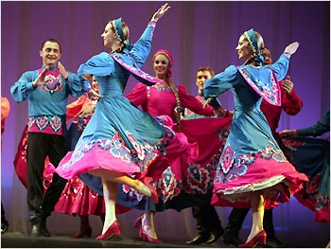

Russian Degree Pathways

CSUN introduces two new degree pathways: the Interdisciplinary Studies Russian Major and the Russian Studies Minor

Why Study Russian?

Whether you are a Liberal Studies Interdisciplinary Program major opting for the Russian Studies Track or take on a Russian Studies Minor to complement your major field, your education will be enriched by 22 course units in Russian grammar, conversation, civilization, and history. Courses may also be taken individually or in concert with the Russian Language & Culture Immersion Program.

Spring 2013: January 22 -May 18

Course | Title | Days and Times | Units
RUSS 390 | Russian Folklore | T/TH 11:00-12:15 p.m. | 3
RUSS 201 | Intermediate Russian I | T/TH 12:30–1:45 p.m. | 3
RUSS 102 | Elementary Russian II | T/TH 2:00-3:40 p.m. | 4

For all Russian Studies pathways, please contact the Liberal Studies Department for advisement and further information: liberalstudies@csun.edu; 818-677-3300; Education 100. Or contact Dina Mokhnatkin: dmokhnatkin@csun.edu; 818-677-3593 or 818-677-3450.

