Title / Cover Page

Table of Contents
Table of Figures 2
Heading 1-This could be a Chapter Title. The font is no good for most papers, but you can change it from Ariel to Times 3
Sub Heading – this could be a section of a chapter—again the font helps you see it better, but you wouldn’t want to send this to your prof. 3
Sub-sub-heading—you might want a section within a section, but this is somewhat uncommon. 3
Chapter 1: Introduction 3
Section? 3
Chapter 2: Second Chapter…literature review…see how I changed the font to Times, bold, 12point? 3
Bibilography 3

Table of Figures
Figure 1: Climograph: Santa Monica, CA (This could be a map or other graphic) 4

Table of Maps
Map 1: A map you might place in the space above. 4

Body of your paper…erase this if you’re using this as a template.

Heading 1-This could be a Chapter Title. The font is no good for most papers, but you can change it from Ariel to Times
Normal paragraph—the normal heading is for regular text…it’s also called body text and it’s where most of your writing would go.

Sub Heading – this could be a section of a chapter—again the font helps you see it better, but you wouldn’t want to send this to your prof.

Normal Paragraph

Sub-sub-heading—you might want a section within a section, but this is somewhat uncommon.

Chapter 1: Introduction
Some body text

Section?
Body Text

Chapter 2: Second Chapter…literature review…see how I changed the font to Times, bold, 12point?
Some more body text regarding chapter 2.

Bibilography

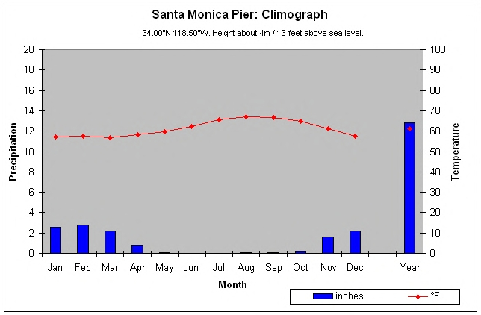
Figure 1: Climograph: Santa Monica, CA (This could be a map or other graphic)

If there was a map here…you’d insert a caption as well
Map 1: A map you might place in the space above.

