California State University, Northridge
Michael D. Eisner College of Education

Fall 2017

EED 681 Classroom Communication and Management Methods

Dr. Susan Belgrad

Mondays 7:00 - 9:45 Juniper 1107

Wednesdays 4:00-6:45 Jacaranda 2522

Dr. Belgrad’s Office: ED 2102
Office phone: 818-677-4901
Office Hours: Tues and Thurs. 3-5:00PM
OR by Appointment

Email: susan.belgrad@csun.edu
Website: https://www.csun.edu/~sb4310

Course Description

This course focuses on the theoretical basis for and the practical implementation of several approaches to classroom management and communication. Emphasis will be on the interrelationship between management and the instructional process (e.g. students’ motivation and characteristics, curriculum considerations, assessment components).

As you instructor it is my principal goal to offer you the perspective (and tools) that help you to make a difference for every student you teach by creating engaged, supported, and caring classroom communities. We will explore many ideas and practices for adapting classroom climate, management and communication practices to key, student-centered philosophies and theories of child/adolescent development and motivation. It is my belief that distinguished teaching is central to each student’s access of his or her talents and “genius.”

“Learning with others is not only in the spirit of the model, it is the model.” Wm. Glasser

Conceptual Framework of the College of Education
The faculty of the Michael D. Eisner College of Education, regionally focused and nationally recognized, is committed to Excellence through Innovation. We believe excellence includes the acquisition of professional knowledge, skills, and dispositions and is demonstrated by the growth and renewal of ethical and caring professionals - faculty, staff, candidates - and those they serve. Innovation occurs through collaborative partnerships among communities of diverse learners who engage in creative and reflective thinking. To this end we continually strive to achieve the following competencies and values that form the foundation of the Conceptual Framework.

  - We value academic excellence in the acquisition of professional knowledge and skills.

  - We value the use of evidence for the purposes of monitoring candidate growth, determining the impact of our programs, and informing ongoing program and unit renewal. To this end we foster a culture of evidence.

  - We value ethical practice and what it means to become ethical and caring professionals.

  - We value collaborative partnerships within the College of Education as well as across disciplines with other CSUN faculty, P-12 faculty, and other members of regional and national educational and service communities.

  - We value diversity in styles of practice and are united in a dedication to acknowledging, learning about, and addressing the varied strengths, interests, and needs of communities of diverse learners.

  - We value creative and reflective thinking and practice.

Course Objectives - Students who successfully complete this course will be able to:

  - Understand the connection between classroom communication, management and effective instruction.
  - Understand the underlying current assumptions regarding child development and discipline and the application of classroom management practices that promote creativity and self knowledge or mindfulness.
  - Analyze the theoretical bases of classroom management and communication: behaviorist, cognitive, constructivist and sociocultural learning .
  - Respond to the challenge to teach all children regardless of diversity, needs and capabilities and the special challenges to educators teaching students from low socio-economic families.
  - Critically evaluate a variety of potential discipline strategies from the Whole Child (ASCD) perspective;
  - Understand and implement reflective thinking processes in class discussions, online forum, written assignments and presentations--and how to transfer these tools into work with K-12 students.
  - Implement a research agenda related to classroom communication and management strategies that promote democracy and/or equity and diversity while using a reflective framework.
  - Articulate your professional objectives of establishing a community of learners in your classroom through review of the California Standards for the Teaching Profession and team work in presenting a collaborative research paper (including 3 literature reviews (précis) that is presented with the use of multiple media.

Course Content
  - Accepting the challenge to teach all our children—theories and perspectives on the definition of education
  - Educating socially, emotionally, physically, linguistically and cognitively-diverse children—challenges and opportunities.
  - Educating children living in poverty—sociological and neurological perspectives.
  - What works in classroom management and why—strategies, research and application.
  - Collaborating with parents and families—the critical importance of home-school communication and teacher leadership to create and maintain positive relationships.
  - Teaching children how to care—Why caring is important for all people.
  - Creating the classroom as a community of learners—examples and characteristics of the learner-centered classroom

Readings (required)

Burke, K. 2008. What to do with the kid who 3rd edition, Thousand Oaks, CA: Corwin Press

Charles, C.M. 2006. Building classroom discipline. 11th ed. MA: Addison Wesley.

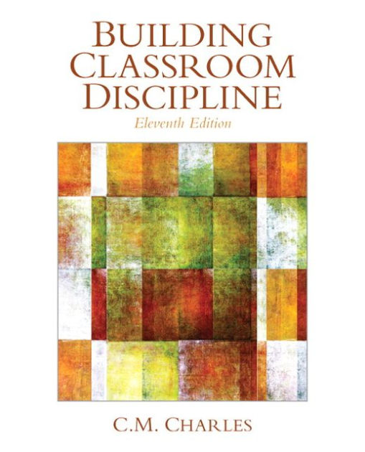

Kohn, A. 2006. Beyond discipline: From compliance to community. Alexandria, VA ASCD. .

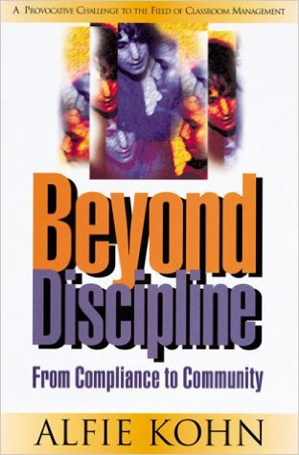

Optional Texts
Kriete, R. 2002. The Morning Meeting Book. Northeast Foundation for Children; 2nd Expand edition.
Recommended
Belgrad, S., Burke, K and Fogarty. R. 2008. The Portfolio Connection. 3rd ed. Thousand Oaks, CA: Corwin Press, A Sage Publications Company.
APA (2009) Publication Manual of the American Psychological Association (6th Edition). Also in the library. Online information about APA formatting http://www.psychwww.com/resource/apacrib.htm

Supplemental Material:
Barth, R. Improving Schools from Within. Chs. 9 & 10.
Selected presentations on cognitive theories of learning; cooperative learning, multiple intelligence theory; intelligent behaviors; tools for the classroom.
Costa, A. “What Human Beings Do When They Behave Intelligently.”
Glasser, Wm. 1985. Control theory in the classroom. NY: Harper & Row.
Kohn, A. 1990. The brighter side of human nature: Altruism and empathy in everyday life. New York: Basic
Kohn, A. 1993. Punished by reward: The trouble with gold stars, incentive plans, A’s, praise and other bribes. Boston, MA: Houghton Miflin.
Kohn, A. 1996 Beyond discipline: From compliance to community. Alexandria, VA: Association of Supervision Curriculum Development.

VII Course Requirements

Methodology:
- Reflective forum participation on classroom management and discipline research;
- Participation as an active group member in a variety of class tasks and activities;
- Group project on schooling in the 21st century;
- Group discussions and session logs on various theories and practices of classroom management
- Review and discuss literature addressing child/adolescent growth and moral development.
- Debate various strategies for improving classroom climate.
- Work collaboratively with class members to establish an inquiry topic on discipline or classroom communication and management that will be presented to the class.

Assignments/Assessments:
Each student will be responsible for organizing course materials and assignments into a portfolio of significant learning. The following items will be included in the portfolio:
1 Reflective forum posts – ten forum posts showing evidence of your reflective response to text readings, assignments
and classroom activities and model applications of course material.
  - Response logs (graphic organizers and session logs) that show evidence of your engagement in reading assignments, class
discussions of and activities;
  - Engagement in a EED 681 Class Debate regarding theories of classroom communication and management;
  - Collaborative presentation on a selected discipline topic;
  - Classroom Communication Plan that shows evidence of achieving course objectives;
  - Portfolio of Significant Achievement and Peer Showcase

PERFORMANCE ASSESSMENT AND ASSIGNMENT SHEET

Name _________________________ Course EED 681

Fall 2017 Date __________ Instructor Dr. Susan Belgrad

PORTFOLIO OF ASSIGNMENTS | Average  1 | Strong 2 | Super 3 | Total
- Forum Posts (5) Max. 2pts. @ |  |  |  | __/10
- Debate--Individual and Group Performance  Score X 5 |  |  |  | __/15
3. Weekly Assignments (8) Max. pts. @5 |  |  |  | __/40
4. Collaborative Presentation  Score X 5 |  |  |  | __/15
- Classroom Communication Plan |  |  |  | __/15
- Portfolio Showcase Score X 5 |  |  |  | __/5
TOTAL POINTS HERE ⇒ |  |  | ________/100
Grading: 94-100 = A (Exceptional) ; 83-94 = B (Solid Quality); 75-82 = C (Passing)

This sheet is submitted at the end of the semester to show evidence of completion of each of the assignments. Students should consult the course standards provided in the syllabus to self assess the quality of work for each item.

This is an intensive, practical graduate course for professional development.
All students entering the course are assumed to have the ability to earn an A or B grade; however this does not mean that all students will automatically receive an A or B.

Guidelines for an A  Exceptional Work  Well-Above Average | - Participation in class discussion and group tasks is active and pertinent  - Understanding of the knowledge base/research findings is reflected in group and individual performance  - Written assignments provide evidence of scholarly work  - Self-assessment of participation and learning outcomes for assigned activities include pertinent defense of exceptional performance.
Guidelines for a B  Basic Graduate | - All assignments provide evidence that an effort has been made to integrate theory and skills into teaching and classroom experience.  - Written or verbal presentation of assignments is of high quality.  - Student actively participates in all class discussions and group tasks.  - All completed course work shows evidence of application of content. Self-assessments reflect ability to meet standards.
Guidelines for a C  Below Average Work | - Assignments are delayed and/or meet minimal requirements.  - Student participates minimally in class discussions and group tasks.  - Course work completed reflects minimal level of acceptability,  - Self-assessments are incomplete or missing.

