How to Implement the Group Isomorphisms Lesson

This lesson should follow the “snap” lesson: http://www.csun.edu/~mathgs/fermat/snap.html

Preliminary Notes

- Students must have already completed the Snap lesson before this lesson!

- Fellows (or K-12 students) create small cardboard equilateral triangles and color one vertex red, one green, and one blue (or any three colors). Vertices must be colored consistently front and back (see below picture). It is helpful for explanation purposes to make a larger triangle for fellows/teachers to use.

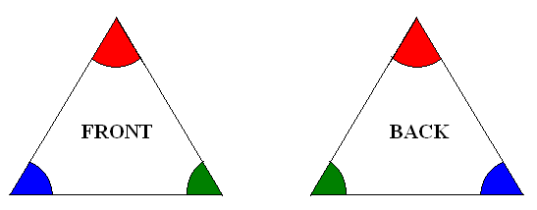

- Label each possible triangle (there should be six) with one of the following names: 1, r, r², f, rf, r²f. See example picture below. Notice that “r” represents taking the “1” triangle and rotating it to the right, and that “r²” represents a second rotation to the right. Finally, “f” means to “flip” the triangle (keeping the top vertex fixed, whichever color it happens to be). Notice that frf equals r², and f r²f equals r, as we are using composition as the operation from right to left. One should recognize this setup as a representation of the group D₃ (or D₆ depending on notation), the group of rigid motions of a triangle. Other relations the teacher/fellow should have students notice is that f ²=1, r ³=1, and rf= f r², r²f= fr.
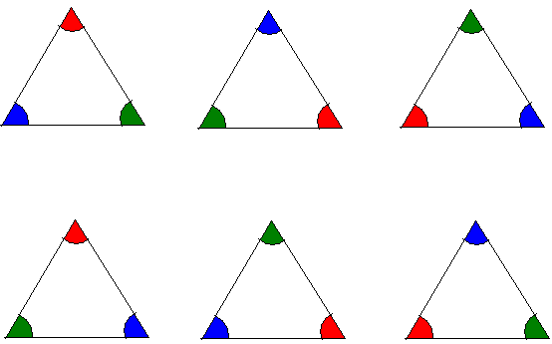
1
r
r²
f
rf
r²f
r²
r²

How to Implement the Lesson

The first objective is to make a “multiplication table” (more technically, a Cayley Table) for the group of rotations and flips of this triangle (see handout Group_Isomorphisms_1.doc). However the triangles have been labeled (make it consistent for the entire class to avoid confusion!), have students color the vertices of the triangles in their Cayley Table accordingly.

Using the relations given in Preliminary Note #3, students in groups complete the Cayley Table using the triangles as manipulatives. Make sure students are careful to do operations from right to left. For example, if they are doing r (left column of table) followed by f (top row of table), they flip the triangle from its starting position (“1”) and then rotate the resulting triangle once to the right. (When we say “once to the right,” we mean to turn the triangle clockwise until a vertex is pointing straight up.)

Students use the Cayley Table, with the guidance of teacher/fellow, to confirm that the Triangle group satisfies the properties of a group: existence of identity, existence of inverses for each element, associativity, and closure (one of our students actually expressed this for Snap by saying that you don’t ever somehow get a “G” when you do the operation).

Isomorphisms

For the isomorphisms part of the lesson, the teacher/fellow must present, on a very basic level, the notions of one-to-one and onto. For this, students must be familiar with the concept of a function. Below are some images a teacher/fellow may use to illustrate the most basic ideas behind these notions. The file Group_Isomorphisms_3.doc is a structured note-taking template for this portion of the lesson. For convenience let’s call the left set X and the right set Y.

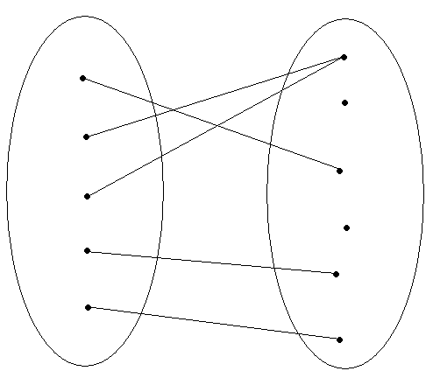
Function: No one point in X is going to two or more points in Y. That is, you don’t have two lines coming out of any point of X and landing on points of Y.

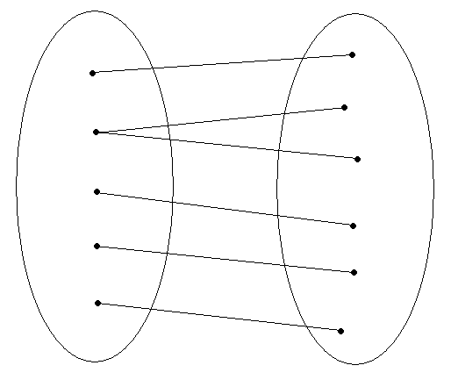
Not a function: the second point in X is going to two points in Y.

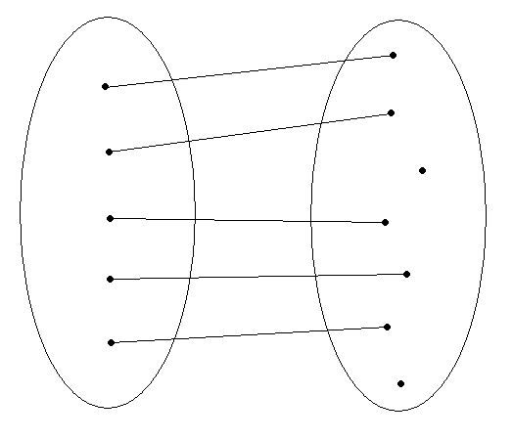
One-to-one: Every point in X goes to exactly one point in Y. That is, you don’t have two or more points going to a single point in Y.

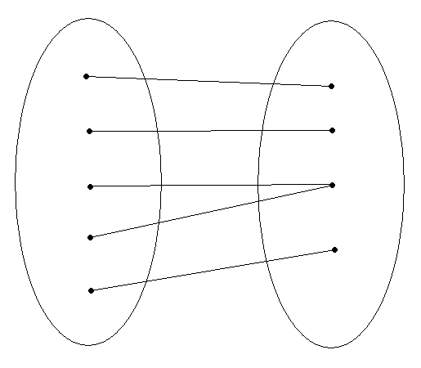
Onto: Every point in Y is touched by (at least) one line coming from points in X. (Notice that this picture is NOT one-to-one. Also notice that the previous picture is NOT onto because two of the points in Y have no line coming from any point in X).

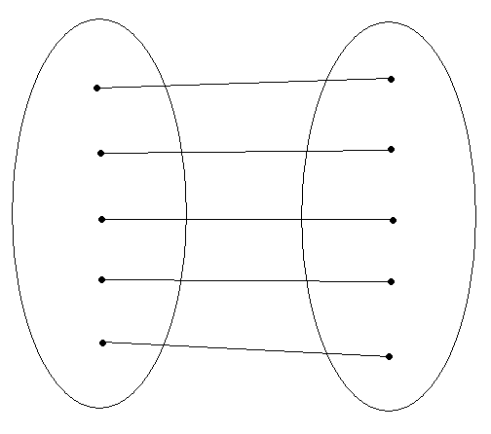
Both one-to-one AND onto: Every point in X is connected with exactly one point in Y, and every point in Y is connected with some point in X. Notice that, in the above picture, there is precisely the same amount of points in X as in Y.

Tell students that if they can show a function is one-to-one and onto, they are 2/3 of the way to showing the function is an isomorphism! Notice that the Snap group has six elements, and our present Triangle group has six elements. So since they have the same number of elements, Snap and Triangle are isomorphic if we can show that they preserve operations.

First we must define an isomorphism! In Group_Isomorphisms_3.doc students can “define” an isomorphism by drawing a line from one member of Snap to one member of Triangle until all elements are connected. Students should already know that the function is one-to-one and onto by the previous paragraph and the way students were instructed to draw the lines. This and the remaining work below should be done in groups.

Now students need to confirm that the chosen function is operation-preserving. Remember that in Snap the operation is to “Snap” the rubber bands once the two letters are on the geoboard. In the Triangle group, the operation is “composition” (right to left) of flips and rotations. Suppose students chose to match in the following way:

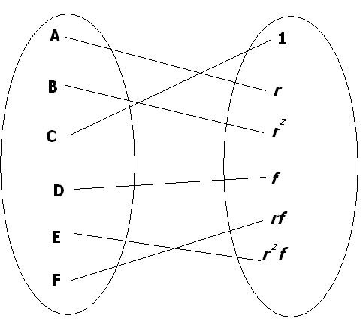
Now students proceed to check the operations. (The file Group_Isomorphisms_2.doc is helpful to remind students of the Cayley Tables of Snap and Triangle, since this lesson takes place over several days.) A Snap B is B, but (r)( r²)=1 and B does not correspond with 1 in the above drawing. So, students must choose another function, because the one they created is not operation-preserving. Suppose they now try the following one:

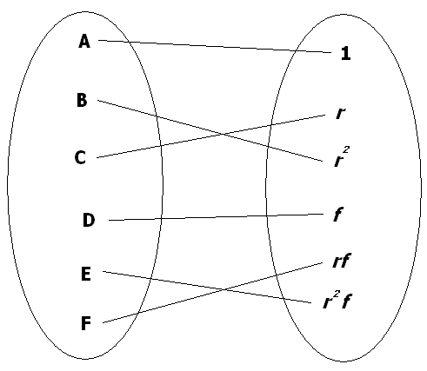

Now A Snap B=B and (1)(r)=r, and B corresponds with r. Similarly, A Snap C, A Snap D, etc. and B Snap A, C Snap A, D Snap A, etc. work out as well. This is because A (the identity of Snap) was mapped to 1 (the identity of Triangle). However, we are not done! Notice that D Snap D = E, but (f)(f) = 1 and E does not correspond with 1. This should reveal to students that f should be mapped from something in Snap that, when Snapped with itself, gives the identity. We check the Cayley Table and see that B Snap B = C Snap C = F Snap F = A.

With lots of work and guidance, students should confirm that a (the?) correct solution is: 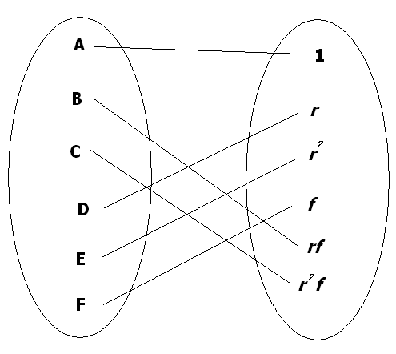

As a wrap-up, explain to students that, since we could find an isomorphism between Snap and Triangle, in a mathematical way they are the same group.

