Chapter 3
Systems Design: Activity-Based Costing

True/False

1. Direct labor-hours should never be used as a measure of activity in an activity-based costing system.
Level: Medium LO: 1 Ans: F

2. When there is a great deal of product diversity, activity-based costing will generally yield more accurate product costs than traditional overhead application rates based on direct labor or machine hours.
Level: Medium LO: 1 Ans: T

3. Product-level activities relate to specific products and typically must be carried out regardless of how many batches are run or units of product are made.
Level: Medium LO: 1 Ans: T

4. The first-stage allocation in activity-based costing is the process by which overhead costs are assigned to activity cost pools.
Level: Easy LO: 1 Ans: T

5. In activity-based costing, there are a number of activity cost pools, each of which is allocated to products using its own unique measure of activity.
Level: Easy LO: 1 Ans: T

6. The activity rates in activity-based costing are computed by dividing the overhead in each production department by its direct labor-hours.
Level: Easy LO: 2 Ans: F

7. The activity rates in activity-based costing are used to determine how quickly a particular task should be done.
Level: Easy LO: 2 Ans: F

8. In activity-based costing, unit product costs computed for external financial reports include direct materials costs.
Level: Easy LO: 3 Ans: T

9. In activity-based costing, unit product costs computed for external financial reports include manufacturing overhead costs that are computed by multiplying activity rates by the direct labor-hours required to produce a product.
Level: Medium LO: 3 Ans: F
10. When a company shifts from a traditional cost system in which manufacturing overhead is applied based on direct labor-hours to an activity-based costing system in which there are batch-level and product-level costs, the unit product costs of high volume products typically decrease whereas the unit product costs of low volume products typically increase.
Level: Medium LO: 4 Ans: T

11. When a company changes from a traditional costing system to an activity-based costing system, the unit product costs of low volume products typically change more than the unit product costs of high volume products.
Level: Medium LO: 4 Ans: T

12. In an activity-based costing system there is no overhead overapplied or underapplied because the costing system is much more accurate.
Level: Medium LO: 5 Ans: F

13. In activity-based costing, manufacturing overhead is credited when overhead is applied to products using activity rates.
Level: Medium LO: 5 Ans: T

Multiple Choice

14. Which of the following would be classified as a product-level activity?
A) Machine setups for standard products.
B) Cafeteria facilities used by all employees.
C) Personnel administration.
D) Testing product prototypes.
Level: Medium LO: 1 Ans: D

15. Would the following activities be best classified at a manufacturer of canned soup as unit-level, batch-level, product-level, or facility-level activities?

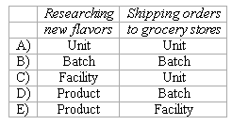
A) A above
B) B above
C) C above
D) D above
E) E above
Level: Medium LO: 1 Ans: D
16. Guerra Electronics manufactures a variety of electronic gadgets for use in the home. Which of the following would probably be the most accurate measure of activity to use for allocating the cost of inspecting the finished products at Guerra?
A) Machine-hours
B) Direct labor-hours
C) Inspection time
D) Number of inspections
Level: Hard LO: 1 Ans: C

17. Designing a new product is an example of a:
A) Unit-level activity.
B) Batch-level activity.
C) Product-level activity.
D) Facility-level activity.
Level: Easy LO: 1 Ans: C

18. Assembling a product is an example of a:
A) Unit-level activity.
B) Batch-level activity.
C) Product-level activity.
D) Facility-level activity.
Level: Medium LO: 1 Ans: A

19. Product engineering is an example of a:
A) Unit-level activity.
B) Batch-level activity.
C) Product-level activity.
D) Facility-level activity.
Level: Medium LO: 1 Ans: C

20. In an activity-based costing system, activity rates are used to:
A) debit Work In Process.
B) set targets for how fast work should be done.
C) debit Manufacturing Overhead.
D) determine the total amount of direct labor-hours required to produce a unit of product.
Level: Hard LO: 2,5 Ans: A

21. In activity-based costing, the total overhead cost in an activity cost pool can be computed by:
A) dividing the total activity in the activity cost pool by the activity rate for the activity cost pool.
B) multiplying the total activity in the activity cost pool by the activity rate for the activity cost pool.
C) dividing the total direct labor-hours in the activity cost pool by the activity rate for the activity cost pool.
D) multiplying the total direct labor-hours in the activity cost pool by the activity rate for the activity cost pool.
Level: Hard LO: 2 Ans: B

22. In activity-based costing, unit product costs computed for external financial reports include manufacturing overhead computed by:
A) multiplying the predetermined overhead rate by the direct labor-hours required per unit of the product.
B) multiplying the activity rate for each cost pool by the direct labor-hours required per unit of the product.
C) multiplying the activity rate for each cost pool by the corresponding amount of activity required per unit of the product.
D) tracing the manufacturing overhead cost to the product.
Level: Medium LO: 3 Ans: C

23. All other things the same, the unit product costs of high volume products will decrease and the unit product costs of low volume products will increase when switching from a traditional costing system to an activity-based costing system if:
A) the activity-based costing system uses direct labor-hours as a measure of activity for at least one activity cost pool.
B) the activity-based costing system includes at least one batch-level cost.
C) the activity-based costing system includes at least one unit-level cost.
D) the activity-based costing system uses machine-hours as a measure of activity for at least one activity cost pool.
Level: Hard LO: 4 Ans: B

24. In an activity-based costing system:
A) overhead cannot be overapplied.
B) overhead cannot be underapplied.
C) overhead cannot be overapplied or underapplied.
D) overhead can be either overapplied or underapplied.
Level: Easy LO: 5 Ans: D

25. Jasmine Company uses activity-based costing. The company has two products: A and B. The annual production and sales of Product A is 10,000 units and of Product B is 4,000 units. There are three activity cost pools, with estimated total cost and expected activity as follows:

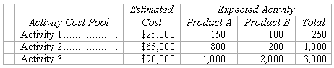

The cost per unit of Product A under activity-based costing is closest to:
A) $6.00
B) $9.70
C) $1.50
D) $3.00
Level: Hard LO: 2,3 Ans: B

26. Belsky Corporation has provided the following data from its activity-based costing system:

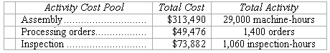

The company makes 490 units of product Q19S a year, requiring a total of 1,080 machine-hours, 60 orders, and 20 inspection-hours per year. The product’s direct materials cost is $46.42 per unit and its direct labor cost is $20.22 per unit.
According to the activity-based costing system, the unit product cost of product Q19S is closest to:
A) $97.64 per unit
B) $66.64 per unit
C) $93.31 per unit
D) $94.79 per unit
Level: Medium LO: 2,3 Ans: A

27. Ravelo Corporation has provided the following data from its activity-based costing system:

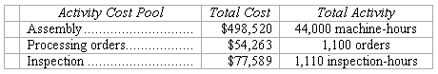
Data concerning the company’s product L19B appear below:

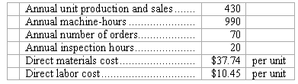

According to the activity-based costing system, the unit product cost of product L19B is closest to:
A) $48.19 per unit
B) $82.31 per unit
C) $85.56 per unit
D) $77.53 per unit
Level: Medium LO: 2,3 Ans: C

28. Robin Company uses activity-based costing to compute product costs for external reports. The company has three activity cost pools and applies overhead using predetermined overhead rates for each activity cost pool. Estimated costs and activities for the current year are presented below for the three activity cost pools:

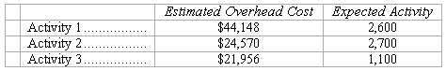

Actual activity for the current year was as follows:

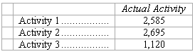

The amount of overhead applied for Activity 2 during the year was closest to:
A) $24,570.00
B) $24,715.00
C) $24,524.50
D) $38,182.25
Level: Medium LO: 2,5 Ans: C

29. Anola Company has two products: A and B. The company uses activity-based costing. The estimated total cost and expected activity for each of the company’s three activity cost pools are as follows:

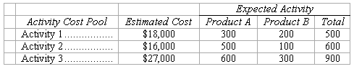

The activity rate under the activity-based costing system for Activity 3 is closest to:
A) $30.00
B) $30.50
C) $90.00
D) $67.78
Level: Medium LO: 2 Ans: A

30. Moyle Corporation has provided the following data from its activity-based costing accounting system:

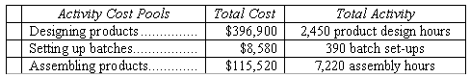

The activity rate for the “designing products” activity cost pool is closest to:
A) $396,900 per product design hour
B) $62 per product design hour
C) $162 per product design hour
D) $52 per product design hour
Level: Easy LO: 2 Ans: C

31. Data concerning three of the activity cost pools of Brevo LLC, a legal firm, have been provided below:

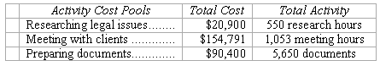

The activity rate for the “meeting with clients” activity cost pool is closest to:
A) $147 per meeting hour
B) $154,791 per meeting hour
C) $37 per meeting hour
D) $68 per meeting hour
Level: Easy LO: 2 Ans: A

32. Senff Corporation uses the following activity rates from its activity-based costing to assign overhead costs to products:

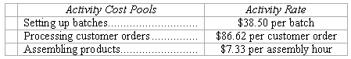

Data concerning two products appear below:

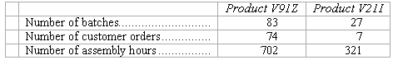

How much overhead cost would be assigned to Product V91Z using the activity-based costing system?
A) $113,774.55
B) $132.45
C) $3,195.50
D) $14,751.04
Level: Easy LO: 3 Ans: D

33. Bera Corporation uses the following activity rates from its activity-based costing to assign overhead costs to products:

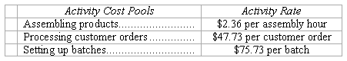

Data for one of the company’s products follow:

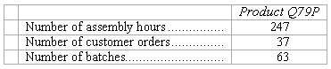

How much overhead cost would be assigned to Product Q79P using the activity-based costing system?
A) $7,119.92
B) $43,659.54
C) $4,770.99
D) $125.82
Level: Easy LO: 3 Ans: A

34. Activity rates from Mcelderry Corporation’s activity-based costing system are listed below. The company uses the activity rates to assign overhead costs to products:

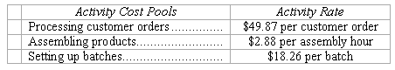

Last year, Product Q06J involved 10 customer orders, 580 assembly hours, and 12 batches. How much overhead cost would be assigned to Product Q06J using the activity-based costing system?
A) $71.01
B) $219.12
C) $2,388.22
D) $42,748.02
Level: Easy LO: 3 Ans: C

35. Diggity Dank Corporation uses an activity-based costing system with two activity cost pools. Diggity Dank uses direct labor hours as the measure of activity in the first activity cost pool and the number of orders in the second activity cost pool. The following information relates to these two activity cost pools for last year:

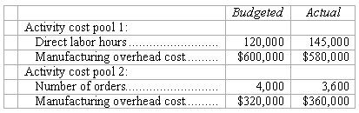

What was Diggity Dank’s under- or overapplied overhead for last year?
A) $17,000 overapplied
B) $20,000 underapplied
C) $27,000 underapplied
D) $73,000 overapplied
Level: Medium LO: 5 Ans: D

Use the following information to answer 36-37
In the past, Hypochondriac Hospital allocated all of its overhead costs to patients based on nursing time. Hypochondriac has decided to switch to an activity based costing system using three activity cost pools. Information related to the new system is as follows:

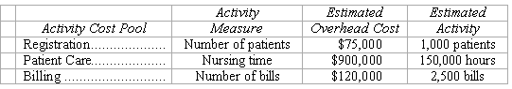

Data concerning two patients follows:

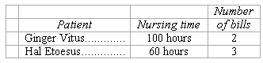

36. Under the new activity-based costing system, how much overhead cost would be assigned to each patient?

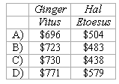
A) A above
B) B above
C) C above
D) D above
Level: Medium LO: 2,3 Ans: D

37. To determine a price for its services, Hypochondriac Hospital takes the total cost assigned to a patient and multiplies that number by two. Compared to the old system, which patients above will be charged more under the new activity-based costing system?
A) Neither patient will be charged more.
B) Ginger Vitus.
C) Hal Etoesus.
D) Both Ginger Vitus and Hal Etoesus.
Level: Hard LO: 4 Ans: D

Use the following information to answer 38-41
Acklin Company has two products: A and B. The annual production and sales of Product A is 600 units and of Product B is 900 units. The company has traditionally used direct labor-hours as the basis for applying all manufacturing overhead to products. Product A requires 0.5 direct labor-hours per unit and Product B requires 0.3 direct labor-hours per unit. The total estimated overhead for next period is $63,322.
The company is considering switching to an activity-based costing system for the purpose of computing unit product costs for external reports. The new activity-based costing system would have three overhead activity cost pools--Activity 1, Activity 2, and General Factory--with estimated overhead costs and expected activity as follows:

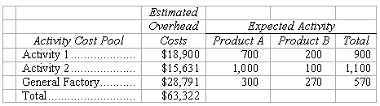

(Note: The General Factory activity cost pool’s costs are allocated on the basis of direct labor-hours.)

38. The predetermined overhead rate under the traditional costing system is closest to:
A) $21.00
B) $14.21
C) $111.09
D) $50.51
Level: Medium LO: 4 Ans: C

39. The overhead cost per unit of Product A under the traditional costing system is closest to:
A) $10.50
B) $55.55
C) $25.26
D) $7.11
Level: Medium LO: 4 Ans: B

40. The predetermined overhead rate (i.e., activity rate) for Activity 1 under the activity-based costing system is closest to:
A) $27.00
B) $94.50
C) $21.00
D) $70.36
Level: Medium LO: 2 Ans: C

41. The overhead cost per unit of Product A under the activity-based costing system is closest to:
A) $25.26
B) $73.44
C) $42.21
D) $55.55
Level: Hard LO: 3 Ans: B

Use the following information to answer 42-43
The controller of Hartis Company estimates the amount of materials handling overhead cost that should be allocated to the company’s two products using the data that are given below:

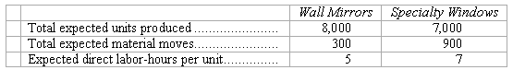

The total materials handling cost for the year is expected to be $38,448.00.

42. If the materials handling cost is allocated on the basis of direct labor-hours, how much of the total materials handling cost should be allocated to the wall mirrors? (Round off your answer to the nearest whole dollar.)
A) $19,696
B) $16,020
C) $19,224
D) $17,280
Level: Easy LO: 4 Ans: D

43. If the materials handling cost is allocated on the basis of material moves, how much of the total materials handling cost should be allocated to the specialty windows? (Round off your answer to the nearest whole dollar.)
A) $18,752
B) $19,224
C) $22,428
D) $28,836
Source: CMA, adapted
Level: Easy LO: 2,3 Ans: D

Use the following information to answer 44-45
Swimm Company allocates materials handling cost to the company’s two products using the below data:

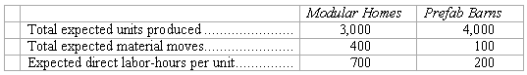
The total materials handling cost for the year is expected to be $72,065.

44. If the materials handling cost is allocated on the basis of direct labor-hours, how much of the total materials handling cost should be allocated to the prefab barns? (Round off your answer to the nearest whole dollar.)
A) $16,014
B) $19,880
C) $36,890
D) $36,033
Level: Easy LO: 4 Ans: B

45. If the materials handling cost is allocated on the basis of material moves, how much of the total materials handling cost should be allocated to the modular homes? (Round off your answer to the nearest whole dollar.)
A) $36,033
B) $57,652
C) $56,051
D) $35,175
Source: CMA, adapted
Level: Easy LO: 2,3 Ans: B

Use the following information to answer 46-50
Brasher Corporation uses activity-based costing to determine product costs for external financial reports. Activity rates computed at the beginning of the year are used to apply manufacturing overhead costs to products. The company has provided the following data concerning its activity-based costing system.
The data used to develop activity rates were:

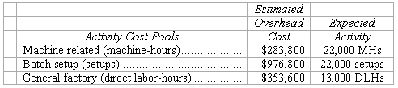

The actual activity for the year was:

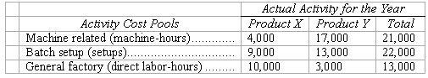

The actual total manufacturing overhead cost incurred for the year was $1,625,400.

46. The activity rate computed at the beginning of the year for the batch setup activity cost pool is closest to:
A) $75.10
B) $108.50
C) $44.40
D) $73.40
Level: Medium LO: 2 Ans: C

47. The total amount of overhead cost allocated to Product X during the year would be closest to:
A) $723,200
B) $661,000
C) $977,000
D) $807,100
Level: Hard LO: 3 Ans: A

48. The credits to the Manufacturing Overhead control account during the year (prior to closing out the balance) would have totaled:
A) $1,613,850
B) $1,625,400
C) $1,611,700
D) $1,601,300
Level: Hard LO: 5 Ans: D

49. The debits to the Manufacturing Overhead control account during the year (prior to closing out the balance) would have totaled:
A) $1,611,700
B) $1,601,300
C) $1,613,350
D) $1,625,400
Level: Hard LO: 5 Ans: D

50. The manufacturing overhead for the year is underapplied (overapplied) by:
A) ($24,100)
B) $24,100
C) ($12,050)
D) $12,050
Level: Hard LO: 5 Ans: B

Use the following information to answer 51-52
Abbe Company uses activity-based costing. The company has two products: A and B. The annual production and sales of Product A is 800 units and of Product B is 600 units. There are three activity cost pools, with estimated costs and expected activity as follows:

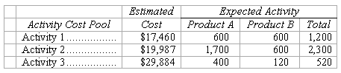

51. The activity rate for Activity 2 is closest to:
A) $11.76
B) $8.69
C) $29.27
D) $33.31
Level: Medium LO: 2 Ans: B

52. The overhead cost per unit of Product B is closest to:
A) $25.90
B) $11.49
C) $34.73
D) $48.09
Level: Hard LO: 3 Ans: C

Use the following information to answer 53-54
Anesni Corporation uses activity-based costing to determine product costs for external financial reports. The company has provided the following data concerning its activity-based costing system:

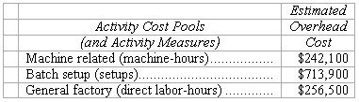

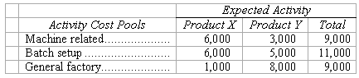

53. The activity rate for the batch setup activity cost pool is closest to:
A) $142.80
B) $64.90
C) $110.20
D) $119.00
Level: Medium LO: 2 Ans: B

54. Assuming that actual activity turns out to be the same as expected activity, the total amount of overhead cost allocated to Product X would be closest to:
A) $606,250
B) $579,300
C) $714,000
D) $661,000
Level: Medium LO: 3
Refer To: 03_07 Ans: B

Use the following information to answer 55-56
Akin Company uses activity-based costing to compute product costs for external reports. The company has three activity cost pools and applies overhead using predetermined overhead rates for each activity cost pool. Estimated costs and activities for the current year are presented below for the three activity cost pools:

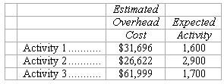

Actual costs and activities for the current year were as follows:

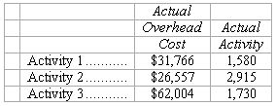

55. The total debits to the Manufacturing Overhead account during the year were closest to:
A) $120,317
B) $120,327
C) $121,153
D) $120,125
Level: Hard LO: 2,5 Ans: B

56. The total credits to the Manufacturing Overhead account during the year were closest to:
A) $120,317
B) $120,327
C) $121,153
D) $120,125
Level: Hard LO: 2,5 Ans: C

Essay

57. Cabalo Company manufactures two products, Product C and Product D. The company estimated it would incur $130,890 in manufacturing overhead costs during the current period. Overhead currently is applied to the products on the basis of direct labor-hours. Data concerning the current period’s operations appear below:

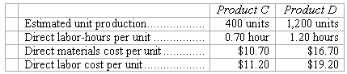

Required:
(a.) Compute the predetermined overhead rate under the current method, and determine the unit product cost of each product for the current year.
(b.) The company is considering using an activity-based costing system to compute unit product costs for external financial reports instead of its traditional system based on direct labor-hours. The activity-based costing system would use three activity cost pools. Data relating to these activities for the current period are given below:

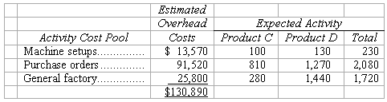

Determine the unit product cost of each product for the current period using the activity-based costing approach.
Level: Hard LO: 2,3,4
Ans:
(a.) The expected total direct labor hours during the period are computed as follows:

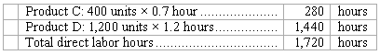

Using these hours as a base, the predetermined overhead using direct labor hours would be:
Estimated overhead cost, $130,890
Estimated direct labor hours, 1,720 = $76.10/DLH
Using this overhead rate, the unit product costs are:

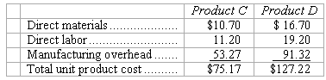

(b.) The overhead rates for each activity center are as follows:

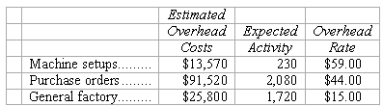

The overhead cost charged to each product is:

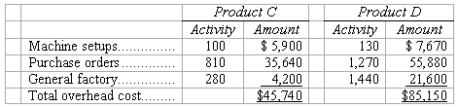

Overhead cost per unit:
Product C: $45,740 ÷ 400 units = $114.35 per unit
Product D: $85,150 ÷ 1,200 units = $70.96 per unit

Using activity based costing, the unit product cost of each product would be:

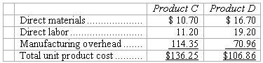

58. Danno Company manufactures two products, Product F and Product G. The company expects to produce and sell 600 units of Product F and 6,000 units of Product G during the current year. The company uses activity-based costing to compute unit product costs for external reports. Data relating to the company’s three activity cost pools are given below for the current year:

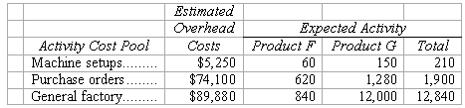

Required:
Using the activity-based costing approach, determine the overhead cost per unit for each product.
Level: Medium LO: 2,3
Ans: The overhead rates for each activity center are as follows:

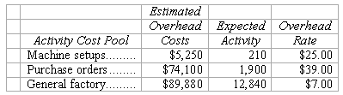

The overhead cost charged to each product is:

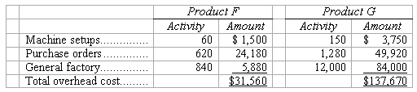

Overhead cost per unit:
Product F: $31,560 ÷ 600 units = $52.60 per unit
Product G: $137,670 ÷ 6,000 units = $22.945 per unit

59. Eaker Company uses activity-based costing to compute product costs for external reports. The company has three activity centers and applies overhead using predetermined overhead rates for each activity center. Estimated costs and activities for the current year are presented below for the three activity centers:

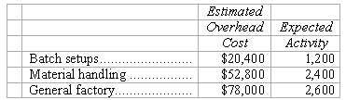

Actual costs and activities for the current year were as follows:

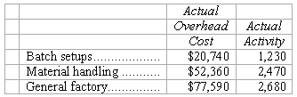

Required:
(a.) How much total overhead was applied to products during the year?
(b.) By how much was overhead overapplied or underapplied? (Be sure to clearly label your answer as to whether the overhead was overapplied or underapplied.)
Level: Hard LO: 2,5
Ans:

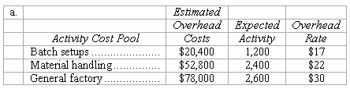

The amount of overhead applied to production is determined as follows:

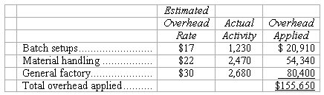

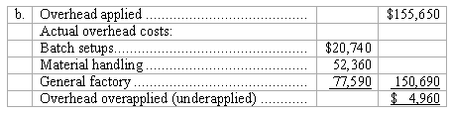

60. Malan Corporation has provided the following data from its activity-based costing accounting system:

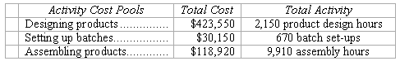

Required:
Compute the activity rates for each of the three cost pools. Show your work!
Level: Easy LO: 2
Ans:

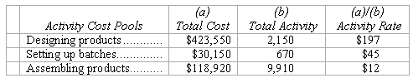

61. Data concerning three of Falkenstein Corporation’s activity cost pools appear below:

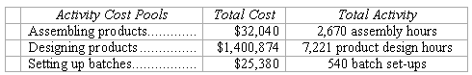

Required:
Compute the activity rates for each of the three cost pools. Show your work!
Level: Easy LO: 2
Ans:

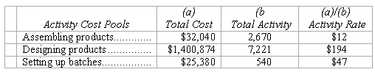

62. Villeda Corporation uses the following activity rates from its activity-based costing to assign overhead costs to products.

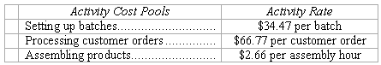

Data concerning two products appear below:

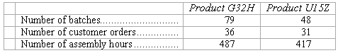

Required:
How much overhead cost would be assigned to each of the two products using the company’s activity-based costing system?
Level: Easy LO: 3
Ans:

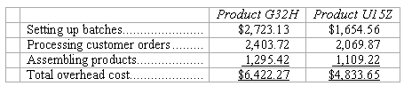

63. Garhart Corporation uses the following activity rates from its activity-based costing to assign overhead costs to products.

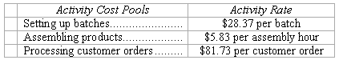

Data concerning two products appear below:

Required:
(a.) How much overhead cost would be assigned to Product R57J using the company’s activity-based costing system? Show your work!
(b.) How much overhead cost would be assigned to Product W17B using the company’s activity-based costing system? Show your work!
Level: Easy LO: 3
Ans:

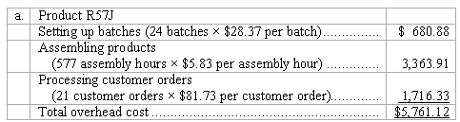

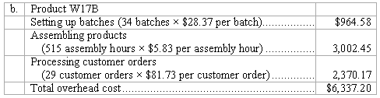

64. Mouret Corporation uses the following activity rates from its activity-based costing to assign overhead costs to products.

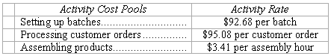

Last year, Product N79A involved 28 batches, 6 customer orders, and 712 assembly hours.
Required:
How much overhead cost would be assigned to Product N79A using the company’s activity-based costing system? Show your work!
Level: Easy LO: 3
Ans:

